NAME:Rishik JK
REG.NO :192511052

CSA1702-ARTIFICIAL INTELLIGENCE
LAB EXPERIMENT

30. Write Prolog Program for Backward Chaining

Aim
To implement backward chaining in Prolog using facts and rules.

Algorithm
- Define facts.
- Define rules based on the facts.
- Ask a query to check the required goal.
- Prolog checks the goal using rules and facts.

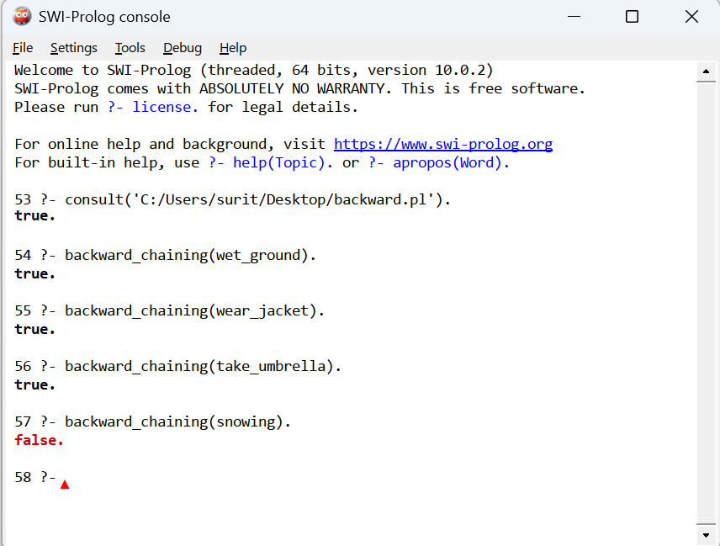

3.Result
Thus, the Prolog program for backward chaining was successfully implemented and executed to verify goals using facts and rules.

